Q5)

Table created successfully….

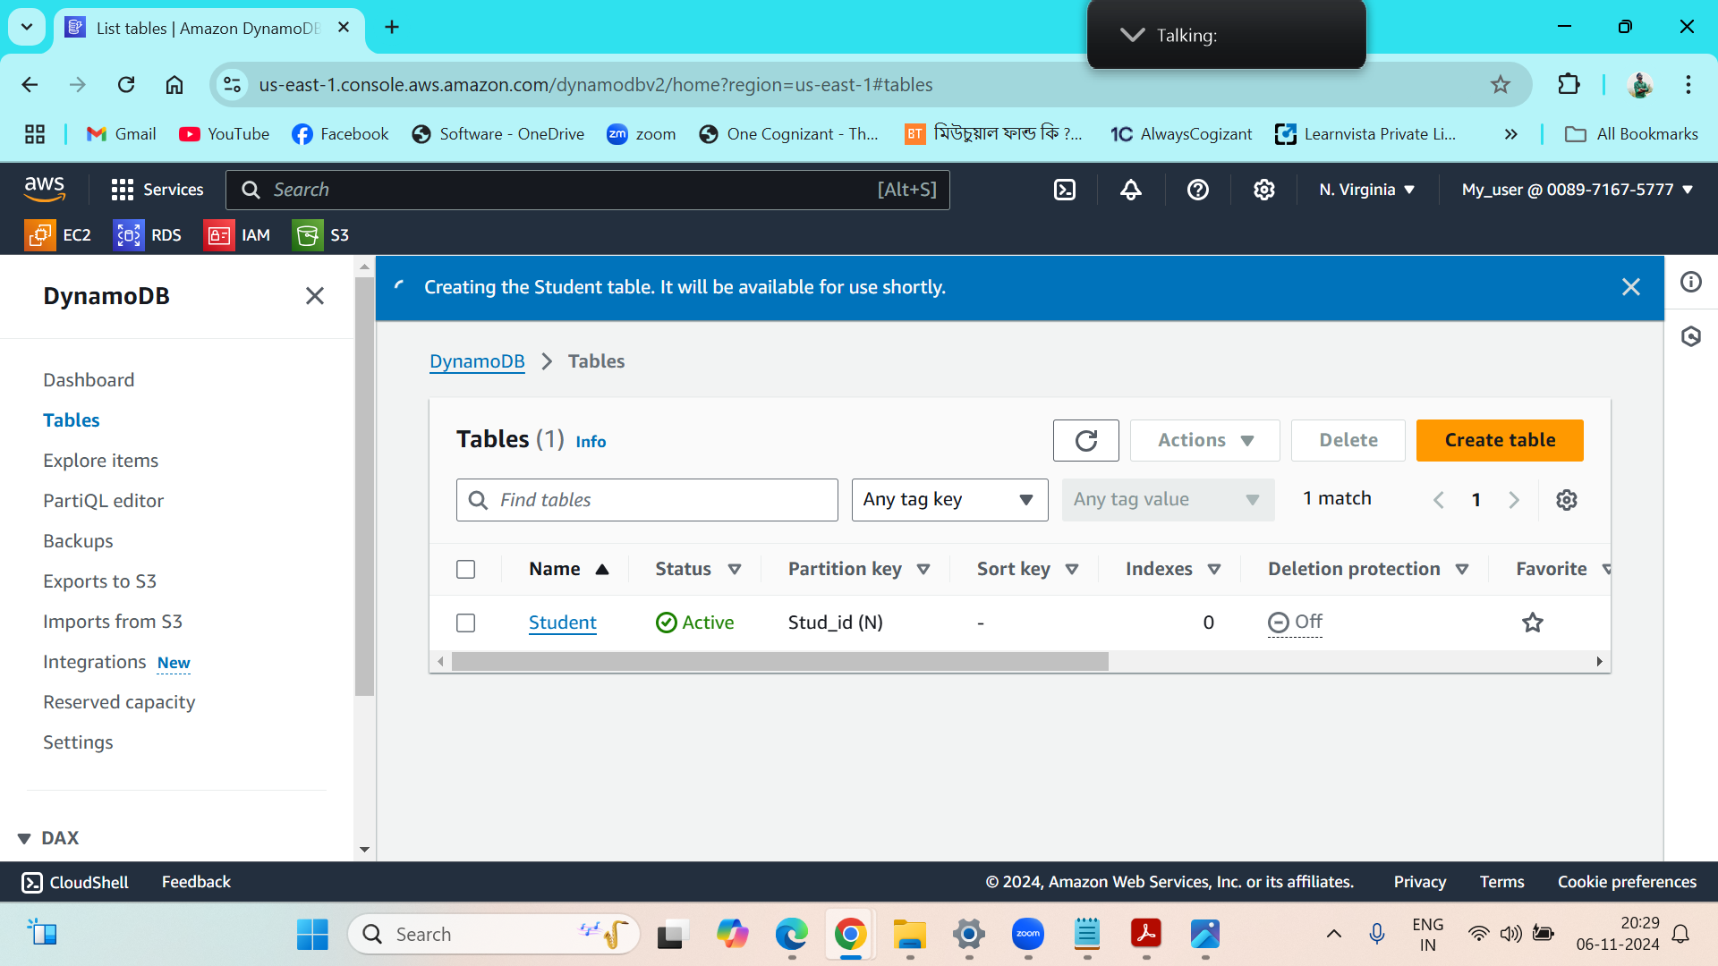

Values inserted inside the ‘Student’ table….

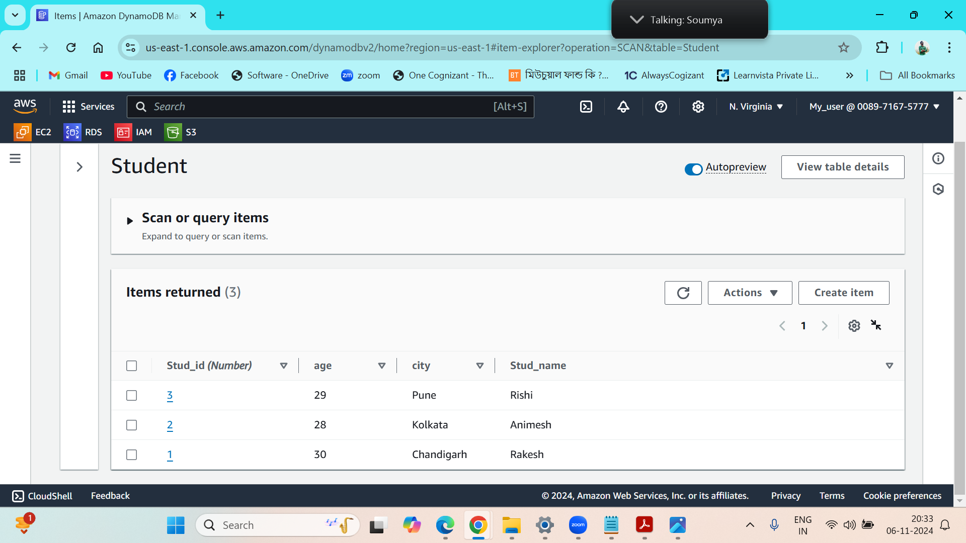

Q4)

Ec2 instance is running….

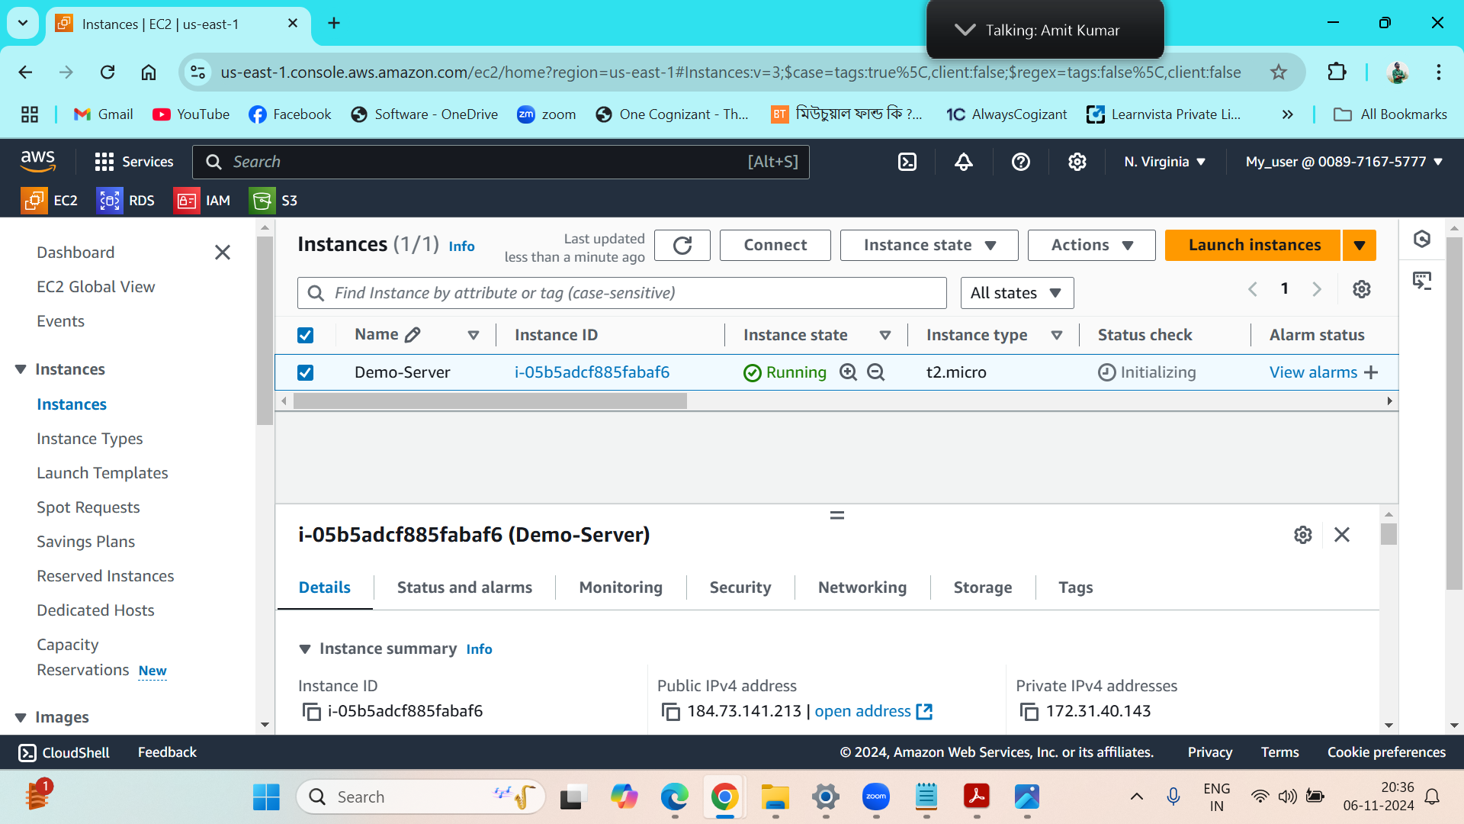

New EBS has been created ….

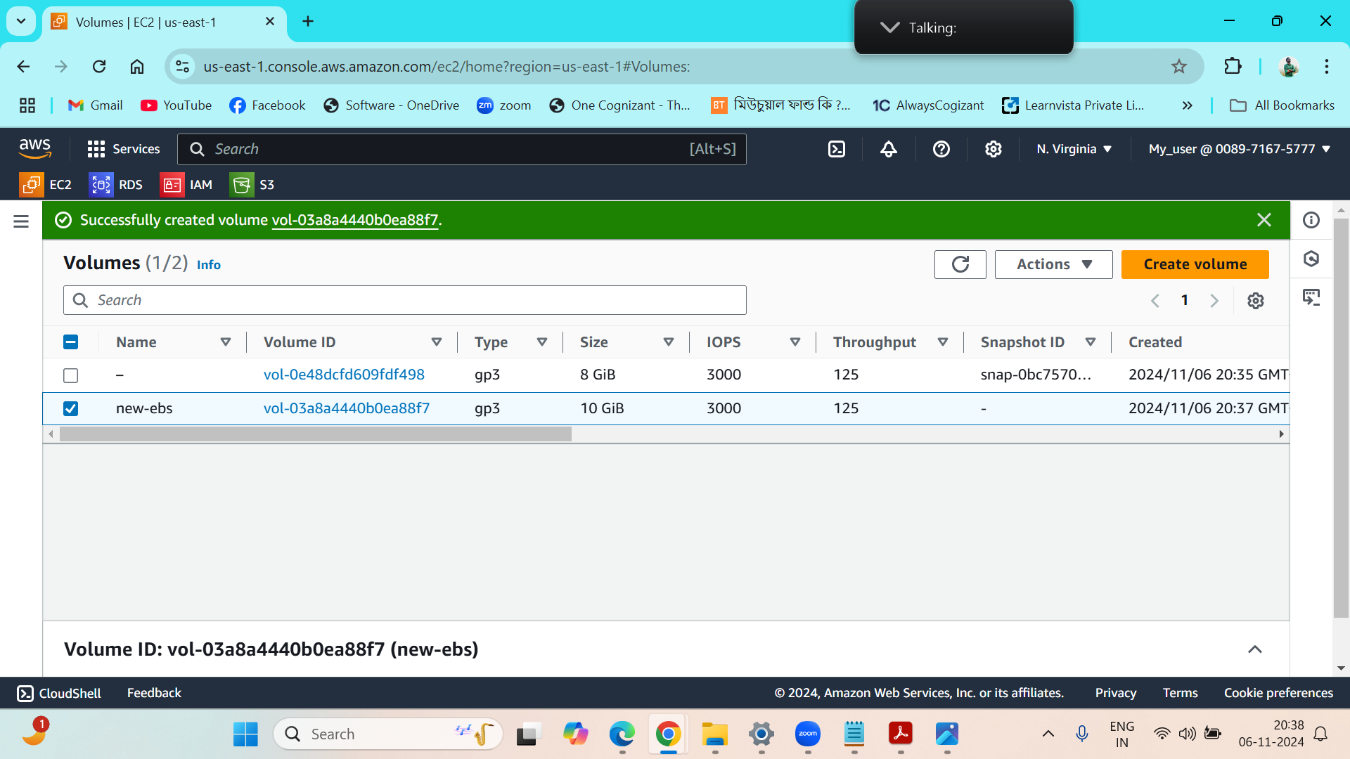

New volume is attached with the instance……

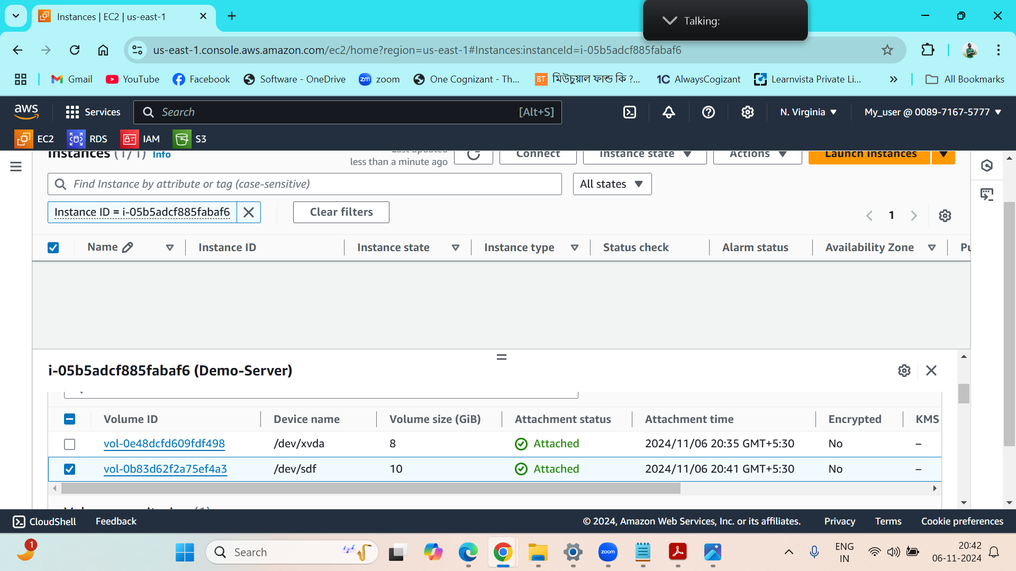

Snapshot of the EBS is created….

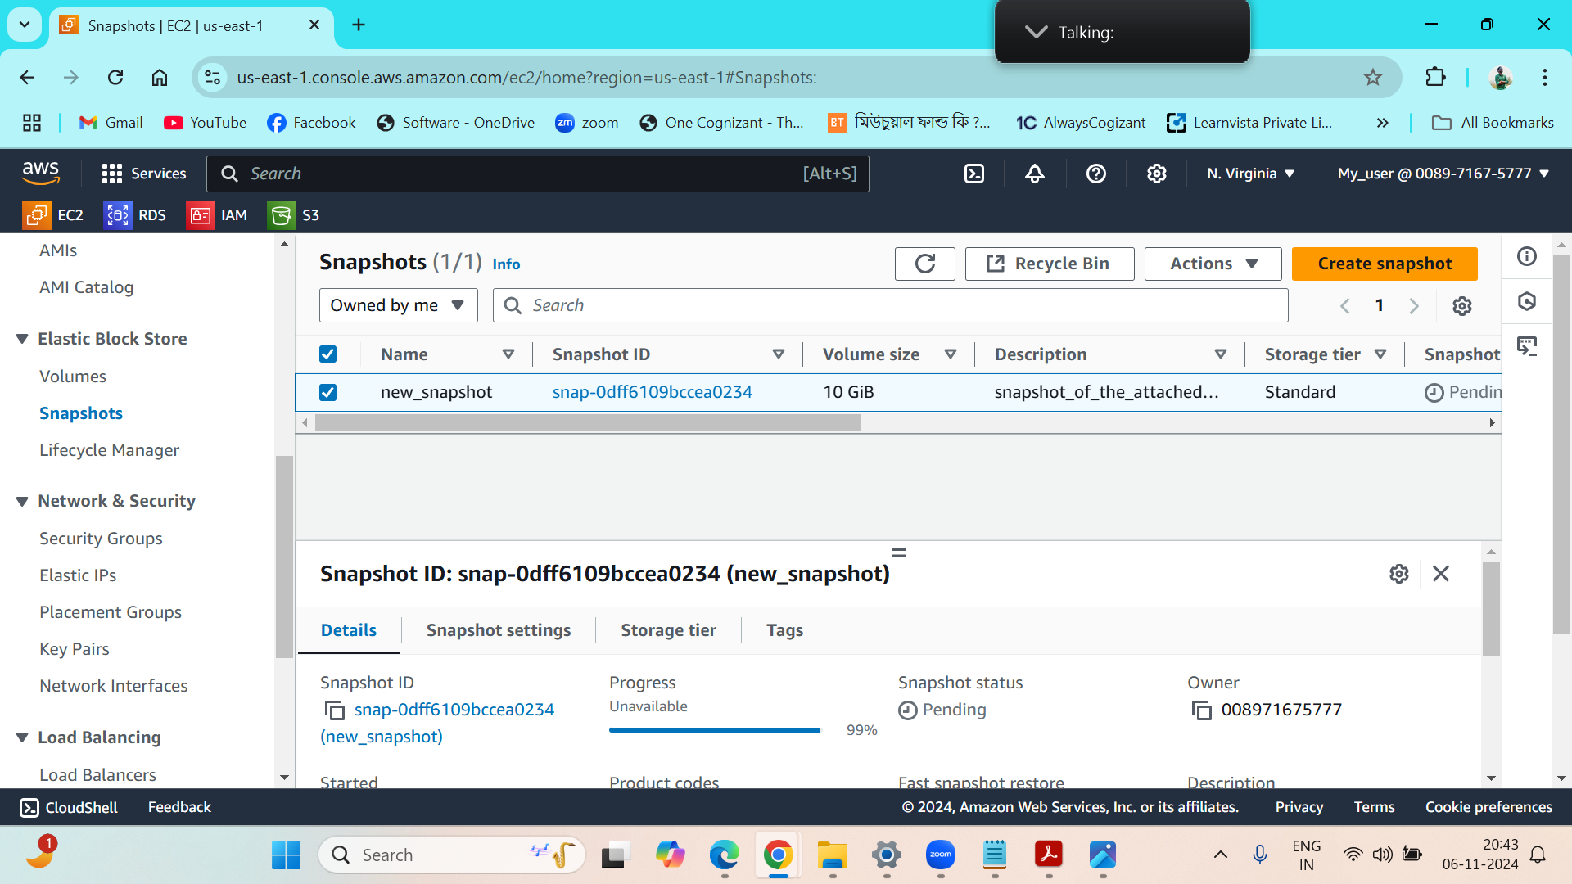

The EBS volume has been detached successfully….

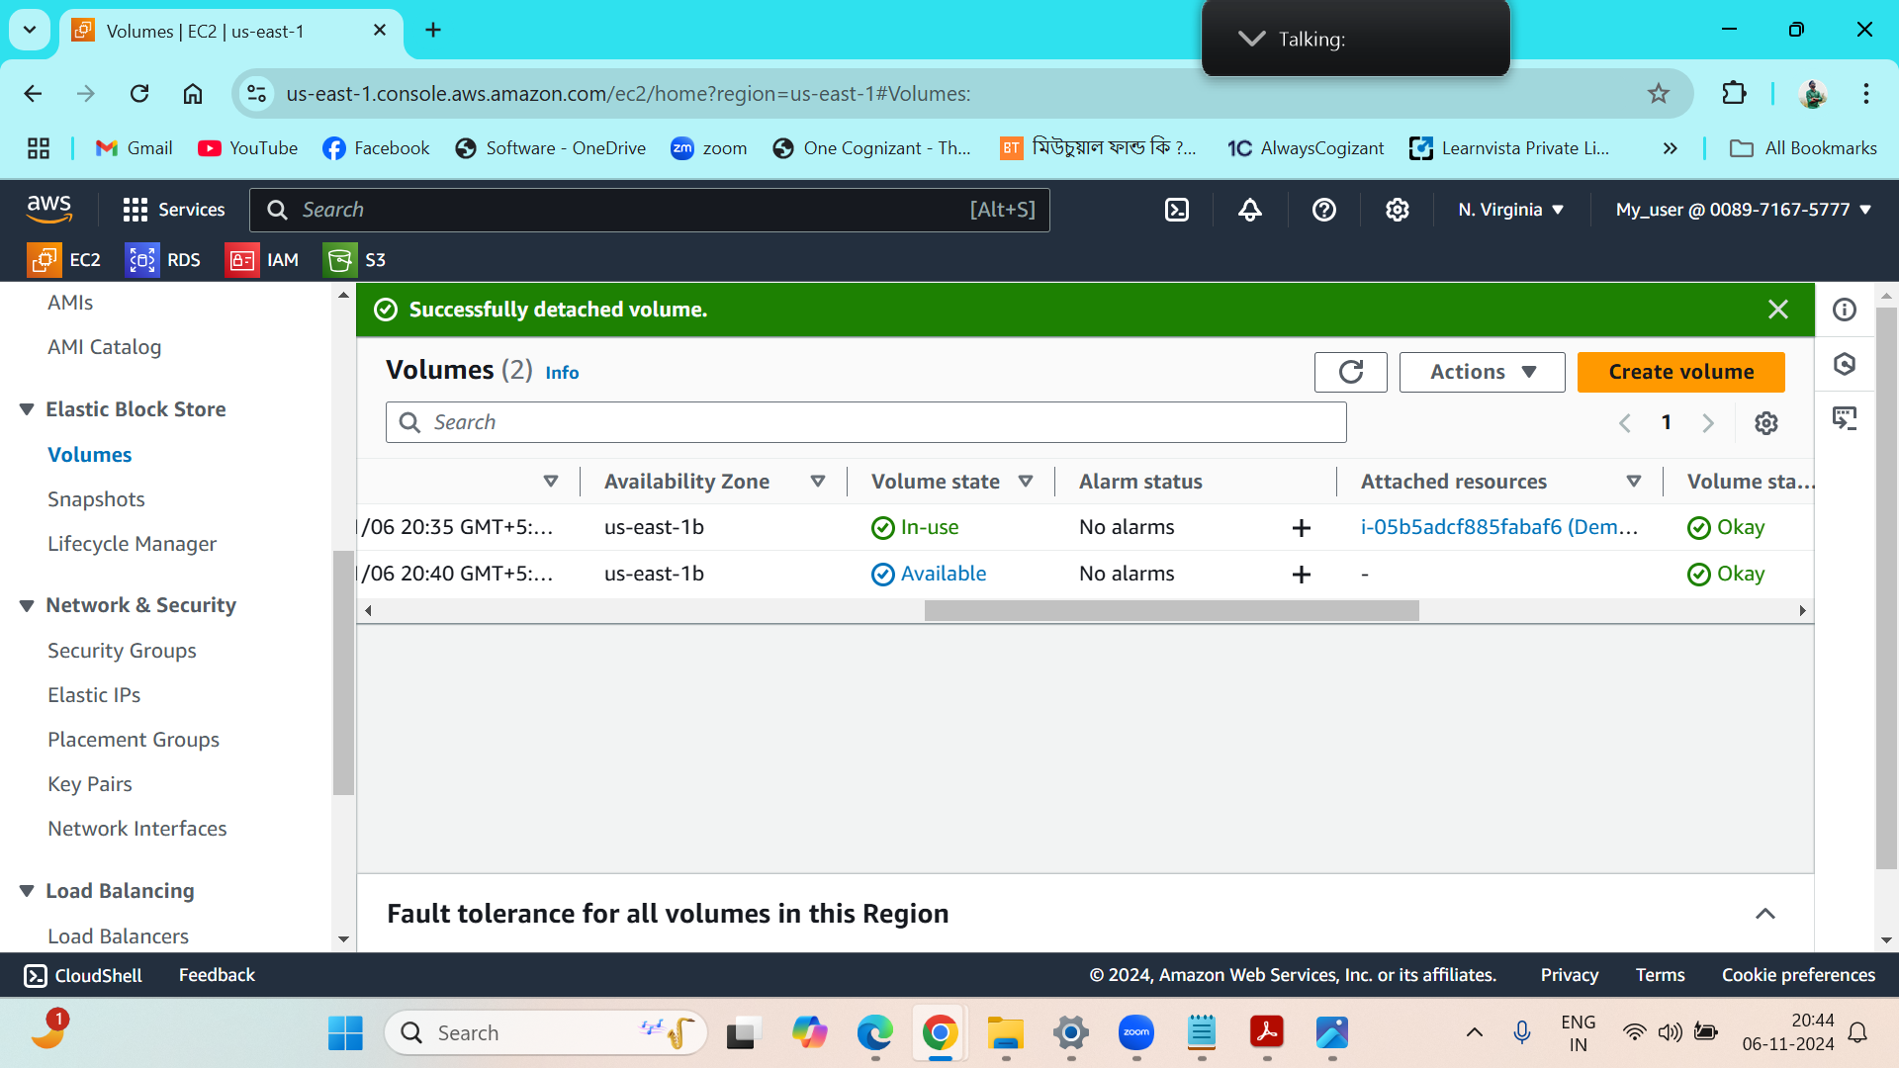

Q8)

One image and one error file have been added to my S3 Bucket…

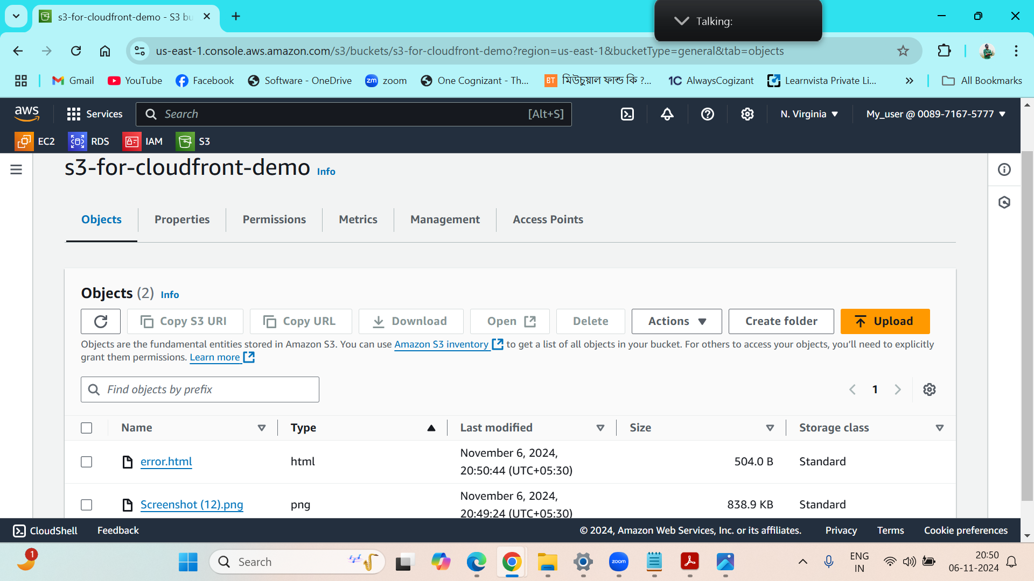

Edited the Bucket policy of the S3 Bucket….

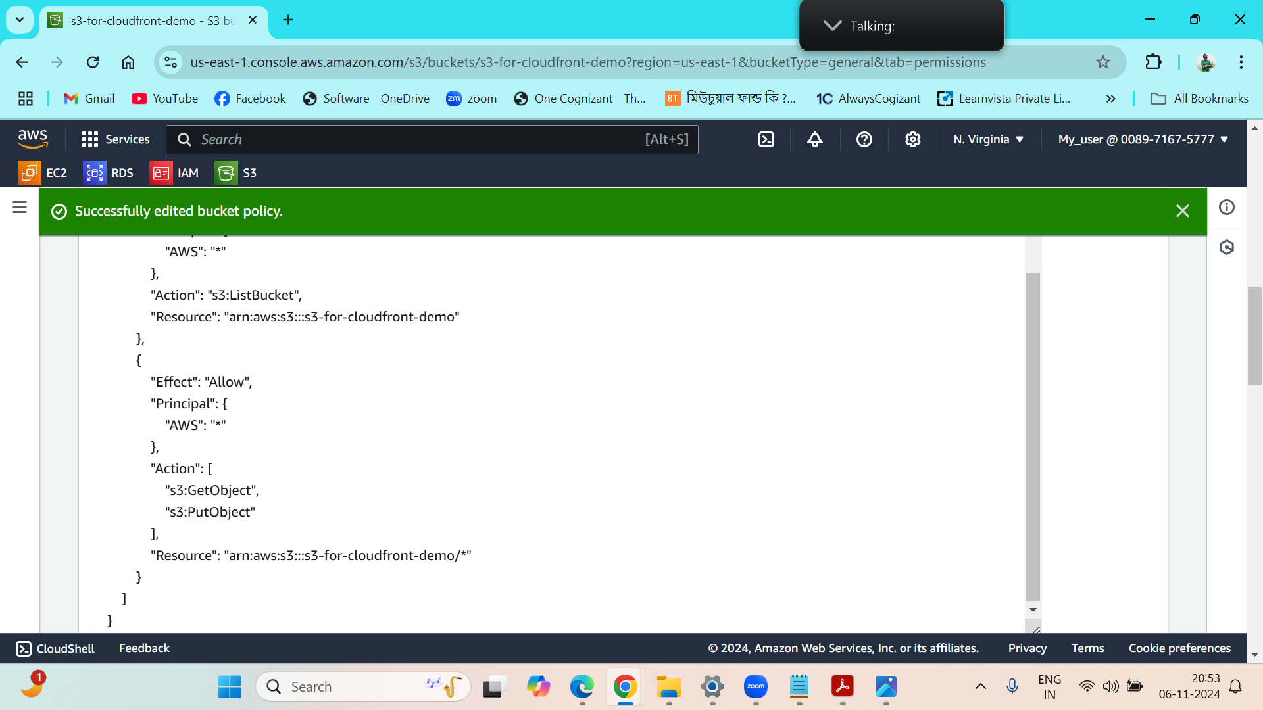

Distribution created for the Cloudfront service…

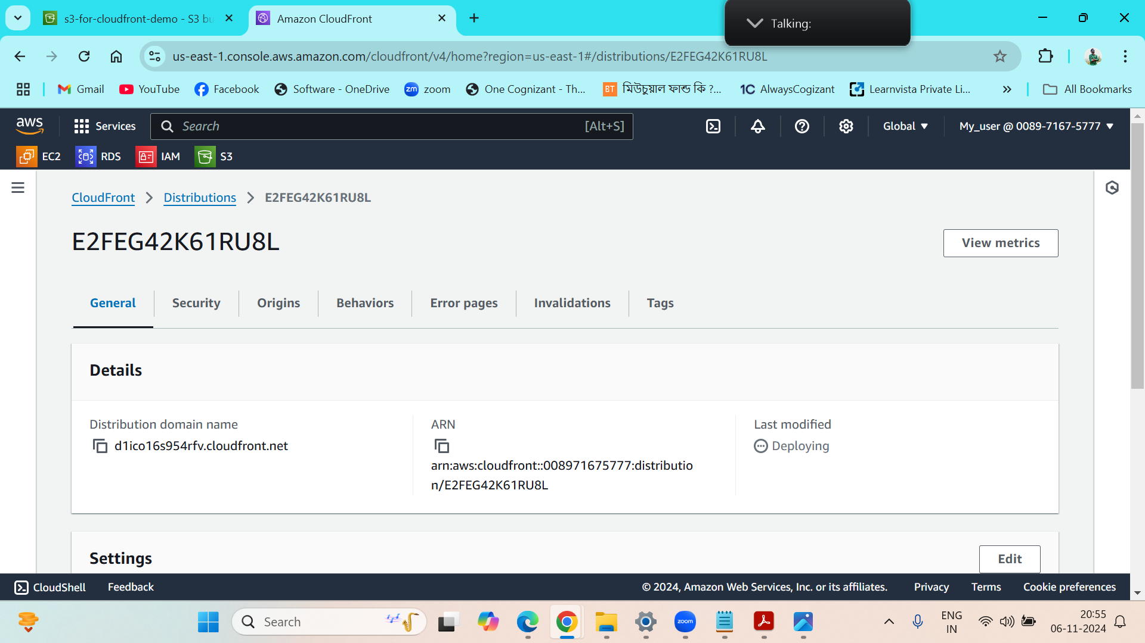

The content is coming from the cloudfront domain now instead of S3 bucket…

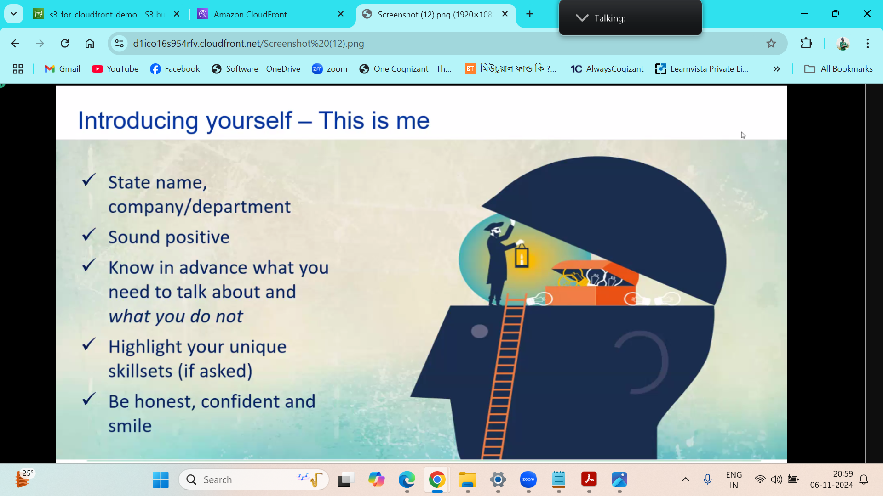

Custom error page is created for showing any kind of error….

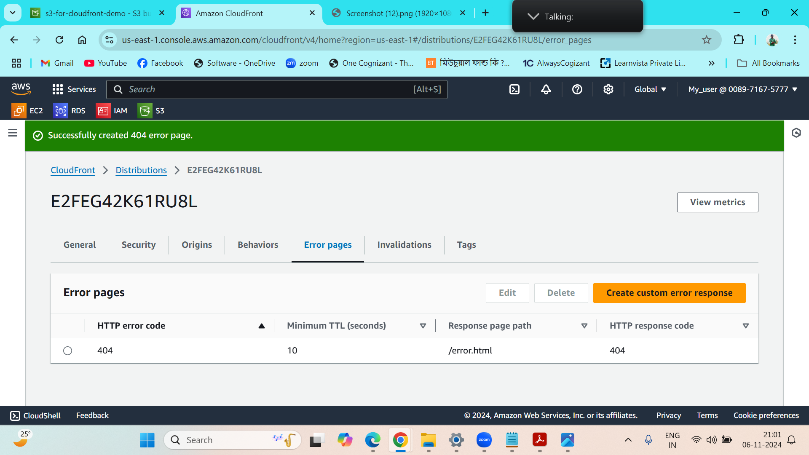

When the filename is wrong ,it is showing the 404 error message to the user…

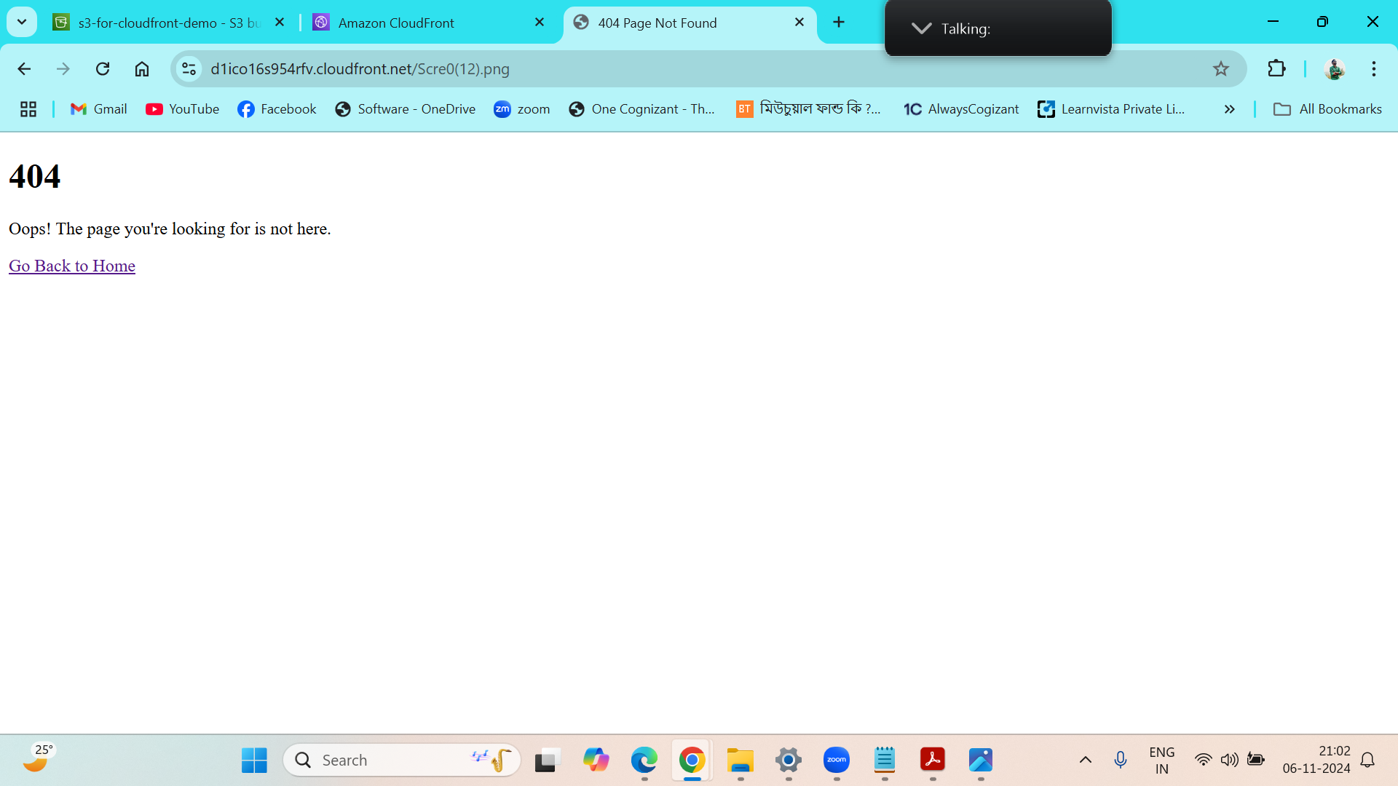

-: THANK YOU :-